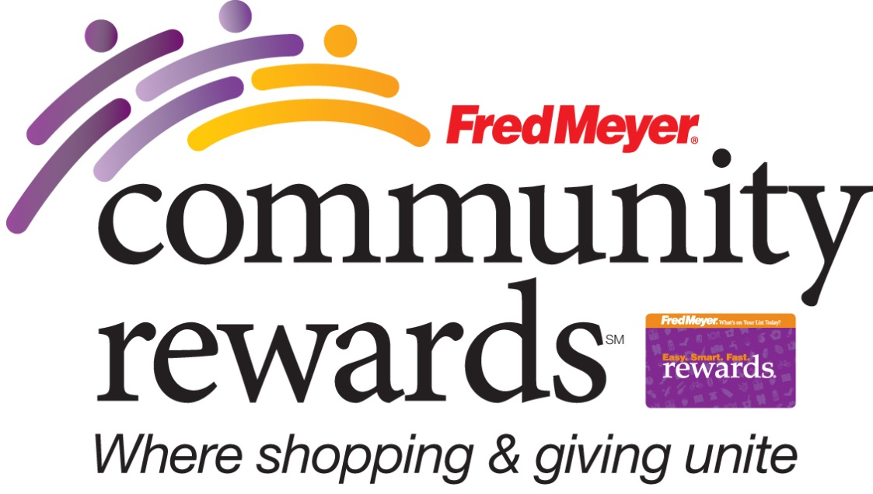
You can help Oregon DECA earn donations
just by shopping with your Fred Meyer Rewards Card!

Fred Meyer is donating $2.5 million per year to non-profits in Alaska, Idaho, Oregon and Washington, based on where their customers tell them to give. Here’s how the program works:
- Sign up for the Community Rewards program by linking your Fred Meyer Rewards Card to Oregon DECA at www.fredmeyer.com/communityrewards. You can search for us by our name or by our non-profit number 88911.
- Then, every time you shop and use your Rewards Card, you are helping Oregon DECA earn a donation!
- You still earn your Rewards Points, Fuel Points, and Rebates, just as you do today.
- If you do not have a Rewards Card, they are available at the Customer Service desk of any Fred Meyer store.
- For more information, please visit www.fredmeyer.com/communityrewards.

